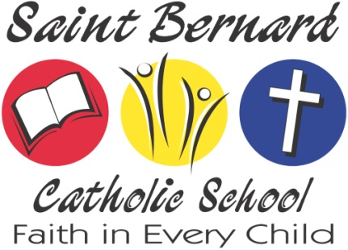

2018-2019 Tuition and Fee Schedule

We are pleased that you are making the choice to send your child(ren) to Saint Bernard Catholic School! At Saint Bernard, our mission is to educate the whole child to serve the world as a responsible Christian. In doing so, we foster not only intellectual growth, but spiritual and emotional growth as well. Our tuition rates are based on what we need to meet our financial obligations and provide your child with the best possible education.

Tuition rates:

The tuition rate for a family is based on 1) the number of children enrolled and 2) whether or not the family is parish-sponsored. To receive the parish-sponsored rate, a family must be an active member of Saint Bernard, Saint Martin, Saint Nicholas or Saint Joseph Catholic Church. Active membership is determined by the priest of the respective parish.

Number of children | 1 |  | 2 |  | 3 |  | 4
Parish-Sponsored/Non-Parishioner | PS | NP | PS | NP | PS | NP | PS | NP
Tuition | $2,730 | $4,290 | $4,146 | $6,438 | $5,562 | $8,586 | $6,540 | $10,020
Textbook Fee | $150 | $150 | $300 | $300 | $450 | $450 | $600 | $600
Technology Fee | $175 | $175 | $350 | $350 | $525 | $525 | $700 | $700
Bus Fee | $10 | $10 | $20 | $20 | $30 | $30 | $40 | $40
Scrip Fee (per family) | $200 | $200 | $200 | $200 | $200 | $200 | $200 | $200
TOTAL Due | $3,265 | $4,825 | $5,016 | $7,308 | $6,767 | $9,791 | $8,080 | $11,560
Cost per child | $3,265 | $4,825 | $2,508 | $3,654 | $2,256 | $3,049 | $2,020 | $2,890

- Parishes fund the balance of the cost of education for each child. The actual cost of educating one child at Saint Bernard during the 2016-17 school year was $6543.85.
- Tuition increased $1.00/day/child for parishioners and for non-parishioners. The tech fee increased by $25/child.
- The $10/child bus fee is to cover expenses for taking children to and from the Rockport City Library.
- There is an additional $300/family bus fee for families whose children ride St. Bernard Bus 1 in the mornings and afternoons.

Payment options:

- Payments may be made by cash, check, or debit/credit card.
- Saint Bernard offers multiple payment plans:
  - Option 1 – Payment in full (There is a 2% discount if paid in full by August 1, 2018.)
  - Option 2 – Ten monthly payments—August through May
  - Other options, such as quarterly or semi-annual payments, may be arranged on a case-by-case basis.
- Automatic payments, either by credit card or automatic deduction from a checking or savings account, are easily arranged and are highly recommended.
Ask us about financial assistance and the various scholarship options available including:

- Indiana Choice Scholarships (vouchers) may pay up to 100% of your child’s tuition
- Tax Credit Scholarships (SGOs) may be available for students who meet income guidelines
- Tuition Assistance Scholarships through the Kremer Foundation and the Christian Education Foundation

